**COMPUTER HARDWARE**

**MEMORY**

RAM

Random-access memory is a form of computer memory that can be read and changed in any order, typically used to store working data and machine code. A random-access memory device allows data items to be read or written in almost the same amount of time irrespective of the physical location of data inside the memory, in contrast with other direct-access data storage media (such as hard disks, CD-RWs, DVD-RWs and the older magnetic tapes and drum memory), where the time required to read and write data items varies significantly depending on their physical locations on the recording medium, due to mechanical limitations such as media rotation speeds and arm movement.

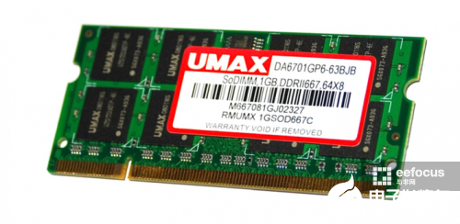

Specification:

DIMM(Dual Inline memory module)

2Giga Bytes of memory

DDR2.667 MHz CL2.5

**MOTHER BOARD**

A motherboard (also called mainboard, main circuit board, or mobo) is the main printed circuit board (PCB) in general-purpose computers and other expandable systems. It holds and allows communication between many of the crucial electronic components of a system, such as the central processing unit (CPU) and memory, and provides connectors for other peripherals. Unlike a backplane, a motherboard usually contains significant sub-systems, such as the central processor, the chipset's input/output and memory controllers, interface connectors, and other components integrated for general use.

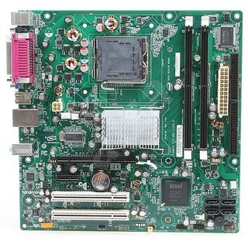

Specifications:

Model number: d945GCNL

Board form factor : MICRO ATX

Socket : LGA775

**HARD DISK DRIVE**

A hard disk drive (HDD), hard disk, hard drive, or fixed disk is an electro-mechanical data storage device that stores and retrieves digital data using magnetic storage and one or more rigid rapidly rotating platters coated with magnetic material. The platters are paired with magnetic heads, usually arranged on a moving actuator arm, which read and write data to the platter surfaces. Data is accessed in a random-access manner, meaning that individual blocks of data can be stored and retrieved in any order. HDDs are a type of non-volatile storage, retaining stored data even when powered off.

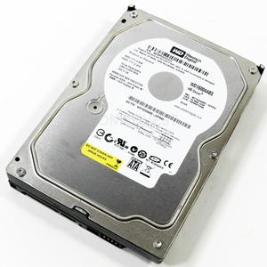 

Specifications:

Model : Western digital WD1600AABS

Connector type : SATA

Data transfer rate : 3.0 Gbps

Form factor : 3.5 inch

Storage size : 160 GigaBytes

Disk RPM : 7200

**PORTS**

In computer hardware, a port serves as an interface between the computer and other computers or peripheral devices. In computer terms, a port generally refers to the part of a computing device available for connection to peripherals such as input and output devices. Computer ports have many uses, to connect a monitor, webcam, speakers, or other peripheral devices. On the physical layer, a computer port is a specialized outlet on a piece of equipment to which a plug or cable connects.

VGA PORT

The Video Graphics Array (VGA) connector is a standard connector used for computer video output. Originating with the 1987 IBM PS/2 and its VGA graphics system, the 15-pin connector went on to become ubiquitous on PCs, as well as many monitors, projectors and high-definition television sets. Other connectors have been used to carry VGA-compatible signals, such as mini-VGA or BNC, but "VGA connector" typically refers to this design.

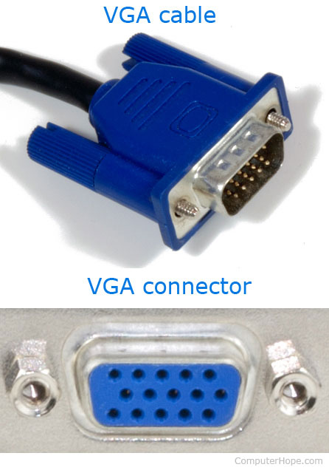

PS/2 PORT

The PS/2 port is a 6-pin mini-DIN connector used for connecting keyboards and mice to a PC compatible computer system. Its name comes from the IBM Personal System/2 series of personal computers, with which it was introduced in 1987. The PS/2 mouse connector generally replaced the older DE-9 RS-232 "serial mouse" connector, while the PS/2 keyboard connector replaced the larger 5-pin/180° DIN connector used in the IBM PC/AT design.

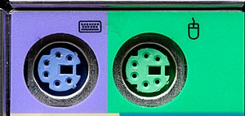

USB PORT

A USB port is a standard cable connection interface for personal computers and consumer electronics devices. USB stands for Universal Serial Bus, an industry standard for short-distance digital data communications. USB ports allow USB devices to be connected to each other with and transfer digital data over USB cables.

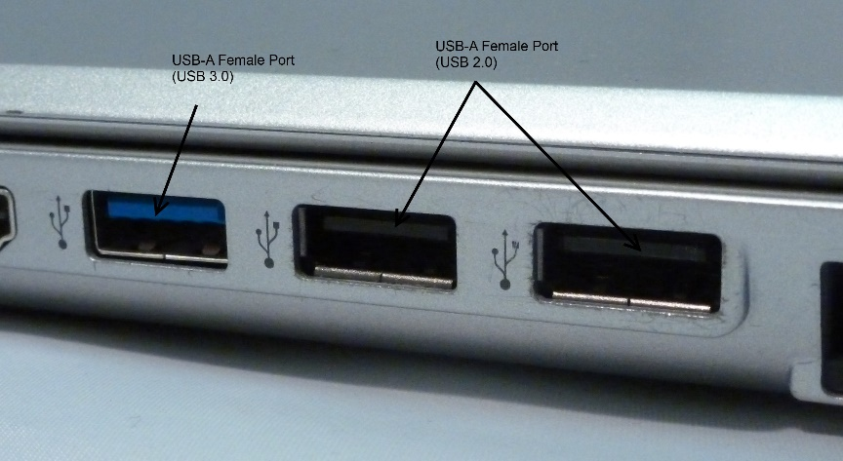

LAN PORT

A LAN port is also known as an Ethernet port. Both terms refer to exactly the same socket on computers, servers, modems, Wi-Fi routers, switches, and other network devices. The term Ethernet port gets its name from the Ethernet protocol.



**BUS SLOTS**

Alternatively known as a bus slot or expansion port, an expansion slot is a connection or port inside a computer on the motherboard or riser card. It provides an installation point for a hardware expansion card to be connected.

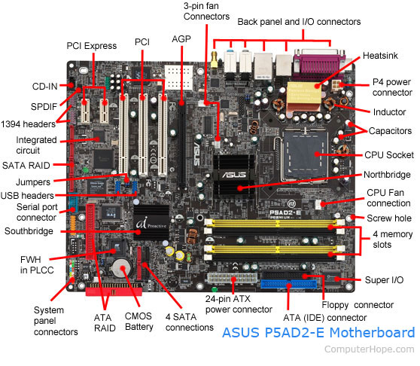

**POWER SUPPLY**

A power supply unit (PSU) converts mains AC to low-voltage regulated DC power for the internal components of a computer. Modern personal computers universally use switched-mode power supplies. Some power supplies have a manual switch for selecting input voltage, while others automatically adapt to the mains voltage. Most modern desktop personal computer power supplies conform to the ATX specification, which includes form factor and voltage tolerances. While an ATX power supply is connected to the mains supply, it always provides a 5-volt standby (5VSB) power so that the standby functions on the computer and certain peripherals are powered.



Specifications:

Input voltage : 115V – 230V ~ 6A/3A . 50/60 Hz

Pin count : 20 + 4